WEB TECHNOLOGIES

LAB TASK 12



Submitted by: TAHIR AHMED KHAN

Registration No: SP21-BSE-086

Class Section: 6B

Submitted to: SIR HASNAIN IQBAL

Department of computer science

Comsats University Islamabad

**Task 1:**

<!DOCTYPE html>

<html lang="en">

<head>

    <meta charset="UTF-8">

    <meta name="viewport" content="width=device-width, initial-scale=1.0">

    <title>Document</title>

    <script src="https://code.jquery.com/jquery-3.6.4.min.js"></script>

</head>

<body>

    <p id="myName"></p>

    <script>

        $(document).ready(**function**() {

**var** fullName **=** "Tahir Ahmed Khan";

      $("#myName").text(fullName)

                    .mouseenter(**function**() {

                      $(**this**).css("color", "red");

                    })

                    .mouseleave(**function**() {

                      $(**this**).css("color", "black");

                    });

    });

    </script>

</body>

</html>

**Output:**

**Task 2:**

<!DOCTYPE html>

<html lang="en">

<head>

    <meta charset="UTF-8">

    <meta name="viewport" content="width=device-width, initial-scale=1.0">

    <title>Document</title>

    <script src="https://code.jquery.com/jquery-3.6.4.min.js"></script>

</head>

<body>

    <p id="myReg"></p>

    <script>

        $(document).ready(**function**() {

**var** regNum **=** "SP21-BSE-086";

            $("#myReg").text(regNum).hide();

            setTimeout(**function**() {

                $("#myReg").toggle(2000);

            }, 2000);

        });

    </script>

</body>

</html>

**Output:**

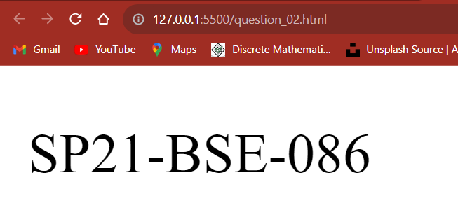

**Task 3:**

<!DOCTYPE html>

<html lang="en">

<head>

    <meta charset="UTF-8">

    <meta name="viewport" content="width=device-width, initial-scale=1.0">

    <title>Document</title>

    <script src="https://code.jquery.com/jquery-3.6.4.min.js"></script>

</head>

<body>

    <p id="demo"></p>

    <p id="demo2"></p>

    <script>

        $(document).ready(**function**() {

**var** myName **=** "Tahir Ahmed Khan";

**var** myReg **=** "Sp21-BSE-086";

            $("#demo, #demo2").text(myName**+** ' ' **+**myReg)

            .fadeIn(4000)

            .fadeOut(6000);

    });

    </script>

</body>

</html>

**Output:**



**Task 4:**

<!DOCTYPE html>

<html lang="en">

<head>

    <meta charset="UTF-8">

    <meta name="viewport" content="width=device-width, initial-scale=1.0">

    <title>Document</title>

    <script src="https://code.jquery.com/jquery-3.6.4.min.js"></script>

</head>

<body>

    <p id="demo"></p>

    <p id="demo2"></p>

    <script>

    $(document).ready(**function**() {

**var** myName **=** "Tahir Ahmed Khan";

**var** myReg **=** "SP21-BSE-086";

        $("#demo, #demo2").text(myName **+** ' ' **+** myReg)

        .slideDown('slow')

        .slideUp('fast');

    });

    </script>

</body>

</html>

OUTPUT:



**Task 5:**

<!DOCTYPE html>

<html lang="en">

<head>

    <meta charset="UTF-8">

    <meta name="viewport" content="width=device-width, initial-scale=1.0">

    <title>Document</title>

    <script src="https://code.jquery.com/jquery-3.6.4.min.js"></script>

</head>

<body>

    <p id="demo"></p>

    <p id="demo2"></p>

    <script>

    $(document).ready(**function**() {

**var** myName **=** "Tahir Ahmed Khan";

**var** myReg **=** "Sp21-Bse-086";

**var** element **=** $("#demo, #demo2");

      element.text(myName **+** ' ' **+** myReg)

             .css("color", "green")

             .hide()

             .delay(2000)

             .show(4000)

             .delay(2000)

             .hide(2000)

             .delay(4000)

             .show(0);

    });

    </script>

</body>

</html>

**Output:**

